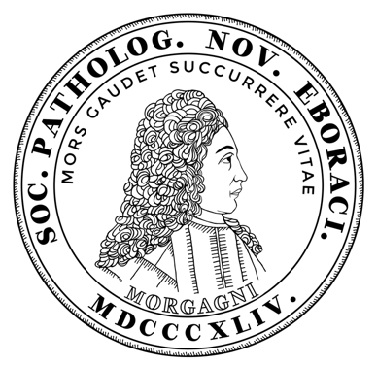
the NEW YORK PATHOLOGICAL SOCIETY
Invites you to attend our
Jean Oliver Annual President’s Symposium
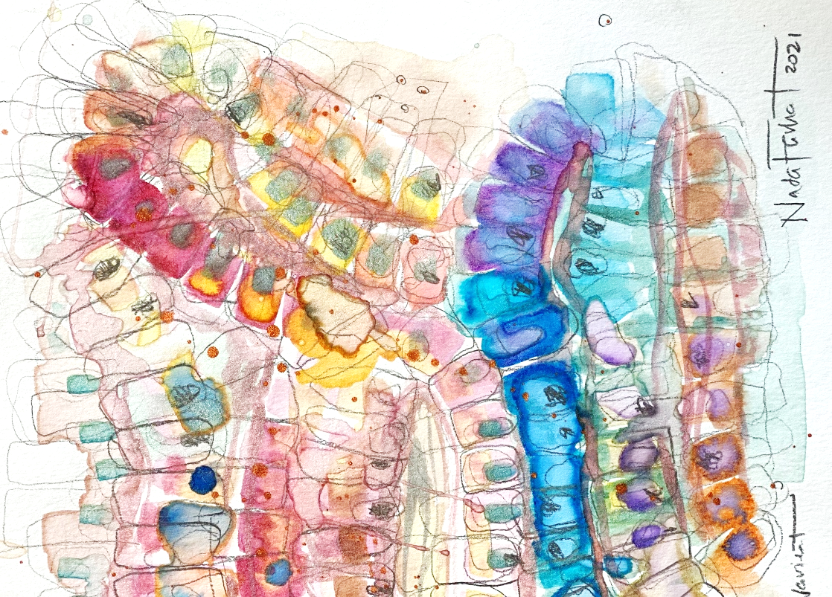
May 1, 2021
8:30am to 12:30pm via Zoom

To register, please RSVP: https://nypathsociety.org

The strength of our society lies with our members and as a token of appreciation for your support, all our 2020-2021 meetings will be free of charge with an annual membership. Continuing Medical Education form (4 credits) and Zoom link will be provided following registration for each meeting.
- NYPS Annual Membership Fee: $125.00 ($60.00 for trainees)
- Member Meeting Fee: Free
- Non-Member Meeting Fee: $50.00 ($15.00 for trainees)

Artwork: Acrylic and pencil on watercolor paper
Artist: Nada Farhat, MD
Program

Diagnostic Challenges in GI and Liver Pathology in 2021

8:30-8:45am Opening Remarks Dr. Isabel Fiel
President, New York Path Society

8:45-9:30am Challenges in Colorectal Polyposis and Hereditary Syndromes
Dr. Wendy Frankel
Kurtz Chair and Distinguished Professor of Pathology
Department of Pathology
The Ohio State University Wexner Medical Center; Columbus, Ohio
9:30-9:40am Q and A

9:40-10:25am Challenges in Diagnosis of Hepatocellular Carcinoma: A Case-Based Discussion”
Dr. Romil Saxena
Professor of Pathology and Professor of Medicine
Director, Gastrointestinal Pathology Fellowship
Department of Pathology and Laboratory Medicine
Indiana University School of Medicine; Indianapolis, Indiana
10:25-10:35am Q and A

10:35-10:45 “In Memoriam”

10:45-11:25am “Challenging Diagnoses of Anorectal Diseases”
Dr. Xiuli Liu
Professor of Pathology
Director, Gastrointestinal and Liver Pathology Fellowship
Department of Pathology, Immunology and Laboratory Medicine
University of Florida; Gainesville, Florida
11:25-11:35am Q and A

11:35-12:15pm “Liver Injury Due to Immune Checkpoint Inhibitors: Challenges in the Diagnosis”
Dr. Matthew Yeh
Professor of Pathology
Director, Gastrointestinal and Hepatic Pathology Fellowship
University of Washington Medical Center; Seattle, Washington
12:15-12:25pm Q and A

12:25pm Wrap-Up

