The Lenox Hill Hospital Department of Pathology mourns the loss of Dr. Harry L. Ioachim, who passed away on June 6, 2021. We are deeply saddened by this great loss. Dr. Ioachim was the Chair of Pathology at Lenox Hill Hospital for a quarter of a century and was a towering figure in his field. He established the Harry L. Ioachim Scholarship at Lenox Hill Hospital to promote resident scholarly activity. The Harry L. Ioachim Immunohistochemistry Laboratory at Lenox Hill Hospital was named in his honor. Our condolences go out to his family and loved ones.
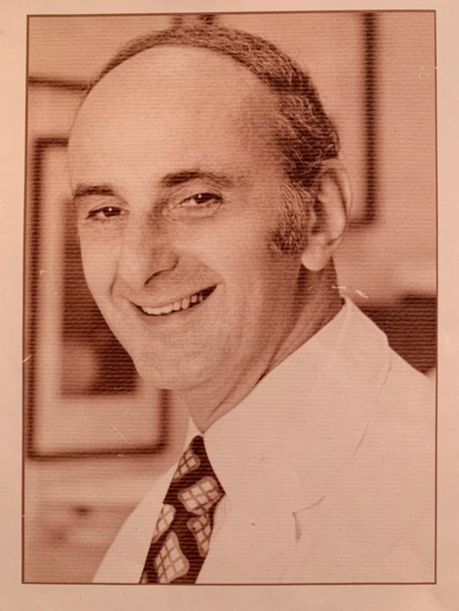
HARRY L. IOACHIM
(October 22, 1924 – June 6, 2021)
Born October 22, 1924 in Bucharest, Romania, Dr. Harry Ioachim grew up under the racial laws of a fascist dictatorship allied with Nazi Germany followed by the years of World War II, the Holocaust and the Communist regime imposed by the conquering Soviet Russia. Under these conditions he graduated medical school, specialized in Pathology, wrote scientific papers and advanced to the rank of assistant professor at the University of Bucharest. In difficult conditions, he was able to leave the country with his wife and one-year-old daughter, and after a year of work at the Institut de Cancer in Paris, he immigrated to the United States. In New York, Dr. Ioachim became a practicing pathologist and research scientist at Columbia Presbyterian Hospital as well as Lenox Hill Hospital where he worked for the next forty years, the last 25 as the Chairman of the Department of Pathology and for three years as President of the Medical Board. At Columbia University College of Physicians and Surgeons, he became an Associate Professor of Pathology. Dr. Ioachim published and edited well-known textbooks of Pathology such as Lymph Node Pathology and well over 100 scientific papers on Cancer Virology and Immunology. He trained many of generations of pathologists and travelled widely, lecturing internationally. Dr. Ioachim was President of the New York Pathological Society and member of other scientific societies. In 2011, at age 85, he published a memoir entitled Looking Back: From the Times of the Nazis and the Soviets to the World of Today.
He is survived by his wife, two daughters, and four grandchildren.

Graveside service will be held tomorrow, Tuesday, June 8th, 2021 at 11 AM in the Mt. Eden Cemetery at 20 Commerce St, Hawthorne, NY 10532.
Contributions in honor of Dr. Ioachim can be donated to the St. Jude’s Children’s Foundation or to the “Harry L. Ioachim Resident Scholarship Award Fund”. Contributions to the fund should be mailed in the form of checks to Debbie Osmond in the address below. Please write Account # SPF 591813 on the check.
Debbie Delligatti Osmond
Associate Director, System Network
Northwell Health Foundation
2000 Marcus Avenue, 2nd Floor
New Hyde Park, NY 11042

Obituary Page: https://www.dignitymemorial.com/obituaries/new-york-ny/harry-ioachim-10221958
Link to St. Jude’s Donation Page: https://www.stjude.org/donate/donate-to-st-jude.html?sc_dcm=58700007088619905&sc_cid=kwp&sc_cat=b&ds_rl=1285465&gclid=Cj0KCQjwh_eFBhDZARIsALHjIKeU74mCvehLELVrhbZ12P9drRELBqQImnT9pgbodBbY1Fl7C-FEWFkaAs0tEALw_wcB&gclsrc=aw.ds

